

My Appointment Card

My name is …………………………………………………………………………………………

My date of birth is ………………………………………………………………………………………

When you come to the surgery for your appointment, please present this booklet to the reception staff or the clinician.

Things you must know about me

Things that are important to me

My likes and dislikes

Things you must know about me.

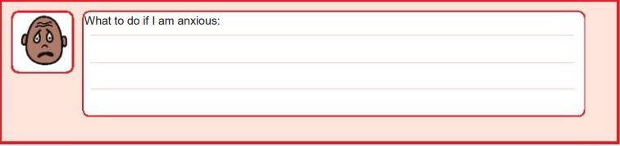

Things that are important to me.

What to do if I am anxious:

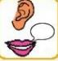

How to communicate with me:

My likes and dislikes

Likes: for example – what makes me happy, things I like to do.

Dislikes: for example – don’t shout, food I don’t like, physical touch.

Things I like/ Please do this:

Things I don’t like/ please don’t do this:

Notes: