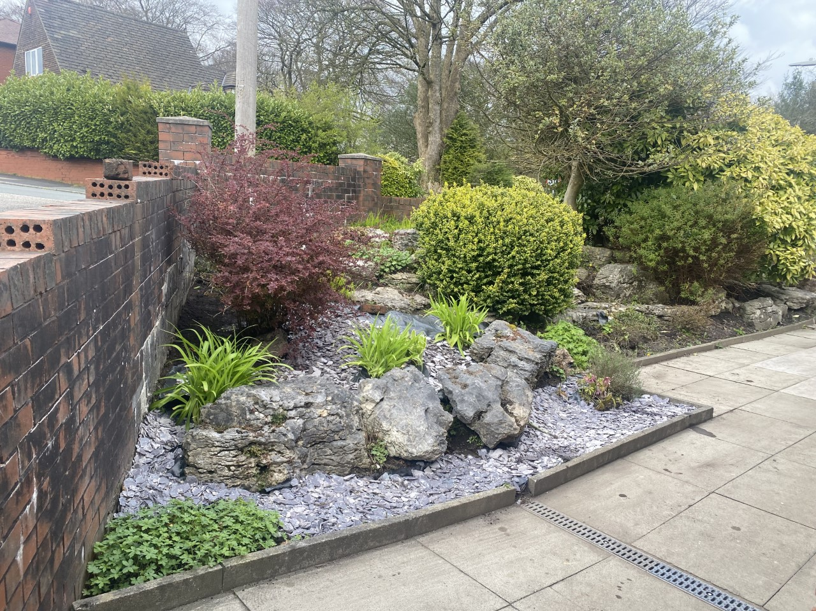

Food bank is in reception, please donate to urban outreach

Several trips to the foodbank have already been made, this is proving to be a success. Please continue to donate and thank you for your contribitions so far.

01204 309206

[Gp.p82023@nhs.net](mailto:Gp.p82023@nhs.net)

**Mandalay’s**

**August**

**Newsletter**

Did Not Attend!

Month on month patients not attending appointments is rising, these are wasted appointments that could go to another patient!

**May – 332**

**June – 368**

**July – 378**

If you are unable to attend your appointment please let the surgery know, we can then allow another patient to be seen in your place.

Prescriptions

We have opened the prescription request box in reception, paper slips can be found on the reception desk to use.

Where possible the prefered method to order would be via email to [**gp.p82023@nhs.net**](mailto:gp.p82023@nhs.net)

**Call Stats**

There has been a significant improvement in call queing times. We will continue to provide the best service we can.



**Annual Reviews**

The surgery will be calling all patients on their birthday month for an annual review. We also offer NHS health checks and ageing well reviews. If you are interested in booking one of these appointments please ask the reception staff .



Please remember to follow us on Facebook Mandalay surgery notice board