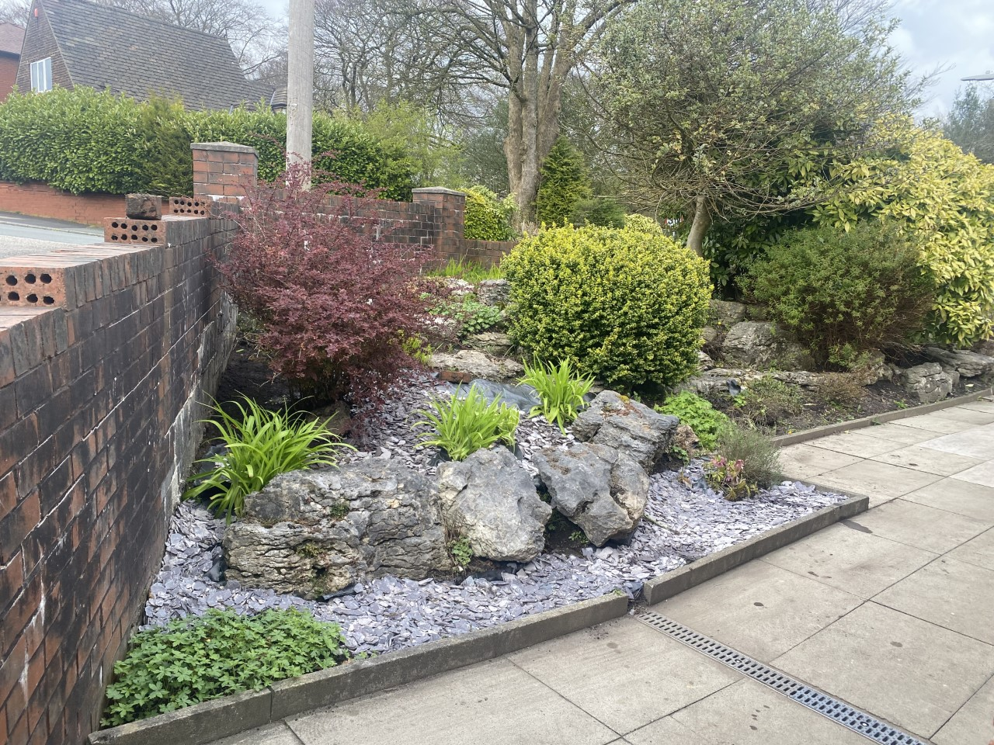

01204 309206

[Gp.p82023@nhs.net](mailto:Gp.p82023@nhs.net)

**Urban Outreach Grub Tub**

**New larger bin in the recption area. Thank you for your continued support.**

**Mandalay’s**

**December**

**Newsletter**

**Prescriptions**

Where possible the prefered method to order would be via email to [gp.p82023@nhs.net](mailto:gp.p82023@nhs.net). Alternatively requests can be made in writing and placed in the box in reception.

**Please contact reception to book your vaccine.**



**Turton PCN**

Did you know that you can book appointments with multiple different clinicians at other surgeries. Please ask reception for more information.

**DID NOT ATTEND!**

**240** patients didn’t attend their appointment in November.

If you are unable to attend your appointment please let the surgery know, we can then allow another patient to be seen in your place.



Please remember to follow us on Facebook

Mandalay Surgery Notice Board