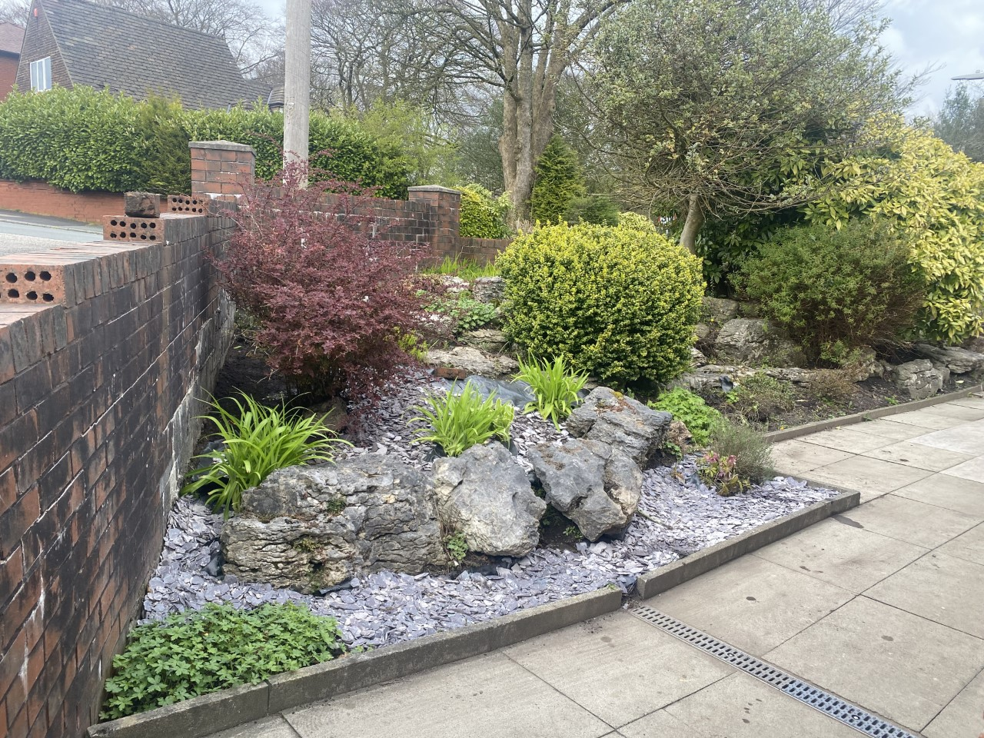

01204 309206

[Gp.p82023@nhs.net](mailto:Gp.p82023@nhs.net)

**Mandalay’s**

**November**

**Newsletter**

Have you had your covid vaccine?

**Prescriptions**

We have opened the prescription request box in reception, paper slips can be found on the reception desk to use.

Where possible the prefered method to order would be via email to gp.p82023@nhs.net

**Urban Outreach Grub Tub**

Thank you for your continued support.

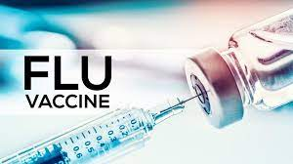



**Are you winter ready?**

**Book your flu jab today**

**DID NOT ATTEND!**

**192** patients didn’t attend their appointment in October.

If you are unable to attend your appointment please let the surgery know, we can then allow another patient to be seen in your place.

**Shingles Vaccine!**

Are you eligible?

Contact reception today to book your vaccine.



Please remember to follow us on Facebook

Mandalay surgery notice board