



**HAPPY NEW YEAR**

Wishing all our patients the very best of health in 2024.

**Contact Number**

**01204 309206**

**Email Address**

[**Gp.p82023@nhs.net**](mailto:Gp.p82023@nhs.net)

**Mandalay’s**

**January**

**Newsletter**

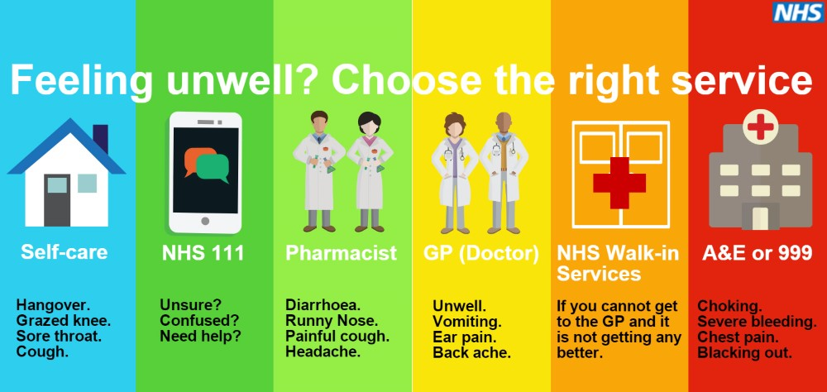

**Prescriptions**

Where possible the prefered method to order would be via email to [gp.p82023@nhs.net](mailto:gp.p82023@nhs.net). Alternatively requests can be made in writing and placed in the box in reception.

**Turton PCN**

Did you know that you can book appointments with multiple different clinicians at other surgeries. Please ask reception for more information.

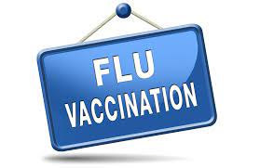 **It is still the flu season**

**Protect yourself and get vacinated**



**DID NOT ATTEND!**

**135** patients didn’t attend their appointment in December.

If you are unable to attend your appointment please let the surgery know, we can then allow another patient to be seen in your place.

Please remember to follow us on Facebook

Mandalay Surgery Notice Board